CCBS7002 COGNITIVE NEUROSCIENCE – GROUP PROJECT FINAL REPORT

**GROUP 8 MORAL TASK**

M-C3-6412-4 Liu, Yuqi

M-C3-6434-1 Chan, Natalia

M-C3-6449-2 Xiao, Xinyun

**THE EFFECT OF EXTRAVERSION-INTROVERSION PERSONALITY TENDENCIES ON MORAL JUDGEMENT – A MINI RESEARCH**

1. **INTRODUCTION**

“Do you know your MBTI type yet?” The MBTI (Myers-Briggs Type Indicator) assessment has gone viral among East Asian countries in recent years. Interestingly, the first MBTI manual was actually constructed and published in 1962 by two Americans, Briggs K. C. and Myers I. B., who were inspired by the work of Jung C. G. on discussing the functions of consciousness and proposing the theory of psychological types (Myers, 1962; Pittenger, 1993). Regardless of its wide application in various placements, it is indeed a self-report with insufficient validity and reliability that claims to screen for personality types (Randall, Isaacson & Ciro, 2017). However, the MBTI assessment does resemble some of the features stated in the Big Five personality constructs, a model that characterizes personality with five factors: openness to experience, conscientiousness, extraversion, agreeableness, and neuroticism, making it a sketch reference for individuals (Roccas et al., 2002; Satow, 2021). Despite the deficiencies in various personality trait indication instruments, extroverts are often described with positive emotional terms, such as excitement, involvement, and enthusiasm; in contrast, introverts are generally said to be quiet, reserved, and insensitive to the surrounding environment (Lei, Yang & Wu, 2015).

The study of morality has a long and diverse history, with the origins of moral psychology tracing back to ancient philosophical writing thousands of years ago. Enthusiasm for research on morality has been revived over the past decade. At the center of this research area is the concept of moral judgment – the interpretation and estimation made in response to a certain behavior, determining its moral quality as either good or bad, or as true or false (Jin & Peng, 2021; Malle, 2021; Myyry, 2022). However, there is no such thing as a specific behavior being absolutely right or absolutely wrong since different individuals possess different outlooks on life, worldviews, and values. Whenever an individual expresses a moral judgment, others would introspect and make inferences about their personality, presenting themselves in a socially acceptable way for the current conditions. Recent studies on moral decision often employ sacrificial dilemma scenarios to provoke decision-making, in which individuals are presented with a situation where they must decide whether or not to sacrifice the life of one person, or a group of people, to save the lives of a large group (Tao et al., 2020).

Several studies have linked the two concepts mentioned, exploring the influence of Extraversion-Introversion on moral judgment, and it has been suggested that people with certain personality traits tend to make more utilitarian and self-serving choices (Karandikar et al., 2019; Tao et al., 2020). Neuroimaging studies have revealed the association of multiple brain areas to extraversion, such as the dorsolateral prefrontal cortex (DLPFC), the anterior cingulate cortex (ACC), the amygdala and many other core regions, while these brain regions were found similar to those involved in decision-making processes, and many have been observed to be damaged in patients with antisocial disorders (Broche-Pérez, Herrera Jiménez & Omar-Martínez, 2016; Heinzelmann, Ugazio & Tobler, 2012; Khani & Rainer, 2016; Lei, Yang & Wu, 2015). It is worth noting that moral decision-making is not necessarily made from moral judgment in many cases, as decisions made by an individual may go against one’s judgment based on the fact that people tend to value the benefits of the current situation more than morality.

The research focus of the current study is to explore moral judgment in terms of extraversion and introversion. Based on the observed differences in the multiple brain regions related to extraversion, it is hypothesized there would be a discrepancy in moral judgments between individuals of extraversion and introversion.

1. **METHODOLOGY**
   1. **Setting and Subjects**

Eleven subjects were recruited, including six females and five males. The subjects are divided into two groups based on their results of the personality measures questionnaire, including an introverted personality traits group (4 subjects with three females and one male, *M*age = 22.50, *SD* = 1.29, age range 21 to 24) and an extroverted personality traits group (6 subjects with three females and three males, *M*age = 24.83, *SD* = 3.60, age range 22 to 32). One subject was classified as having intermediate personality traits. Informed consents were given and signed voluntarily prior to the experiment. All subjects are university students with native verbal and written proficiency in Chinese.

* 1. **Personality Measures**

Eysenck’s personality theory is the most common and dominant among the different models of personality. The Eysenck Personality Questionnaire (EPQ) is a self-report scale assessing personality traits with high validity and reliability confirmed by various psychological experimental studies, yielding two versions for children and adults with different scoring standards for different age groups (Eysenck & Eysenck, 1975, 1993). This assessment includes four subscales: extraversion/introversion propensity scale (E), neuroticism/stability scale (N), psychoticism/socialization scale (P), and lie/social desirability scale (L). The first three subscales are independent, representing the three factors of personality mentioned in Eysenck's personality theory. The last subscale is a validity scale that measures the subject's concealment and pretense, which also represents a stable function of personality. Subjects with higher scores in the L subscale may have lower credibility of the test results, lacking referencing significance; however, this does not mean that the subjects are mentally unhealthy; there might be some unspeakable reasons that caused the subjects' incapability to answer the questions based on their current circumstances. According to the total score obtained on each scale, the standard score is calculated based on the model – *T*=50+10*(*X*-*M*)/*SD*, where the *T*-score is a concept of statistics that describes how far a data point differs from the mean of the dataset, *X* is the specific data value, *M* represents the mean and *SD* (σ) stands for standard deviation, which *M* and *SD* vary for different scales and for different age groups, see table 1. The subjects could be subdivided into five categories based on their EQP-*T*-score: typical extraversion, tending extraversion, intermediate, tending introversion, and typical introversion, in which a lower *T*-score indicates introversion, and vice versa. A modified Chinese version with 88 items would be adopted for this study as a basis for differentiating personality types of subjects as extraversion and introversion (Gong, 1984; Qian et al., 2000). In the current study, subjects indicated as typical introversion and tending introversion are classified as the introverted personality traits group, and subjects indicated as typical extraversion and tending extraversion are classified as the extroverted personality traits group. Subjects indicated as intermediate personality traits would be eliminated from data analysis for the sake of the current research purpose.

**Table 1.** Scoring standards for each subscale of EQP – adult version.

**Note:** P: psychoticism/socialization scale; E: extraversion-introversion propensity scale; N: neuroticism/ stability scale; L: lie/social desirability scale. 均數: mean (*M*); 標準差: standard deviation (*SD*).

* 1. **Moral Judgment and Emotion Task**

The task uses textual descriptions of 10 moral scenarios which were partially adapted from previous approaches that used vignettes to convey the scenarios (Young et al., 2007). Each moral scenario is divided into four parts: background, foreshadow, belief and outcome. First “background” introduces the place or the condition where the story happens. Second, the “foreshadow” is presented to the subjects, it contains a prophetic message about the outcomes. Third, the “belief” shows the protagonist’s beliefs indicating whether the coming result in the next section results from their intentional or unintentional actions. And at the end of one scenario the “outcome” contains the actions actually performed and the results produced. "Intention" contains the beliefs and thoughts of the protagonist about the situation, and "Outcome" is the actual behavior performances of the protagonist and the final outcomes produced by the behaviors. In the experimental design, we made “belief” as first variable of the experiment and it includes both negative and neutral condition. And the “outcome” is the second variable which also contains the two conditions. Therefore, a 2×2 interaction of the two variables constitutes the four conditions of the experiment and is well-designed for now. To more specifically introduce the four conditions:

1. Good purpose results in the happy ending which means no one is injured (neutral belief > neutral outcome）
2. Good purpose results in the sad ending which means the protagonist has no intention of wounding someone, but they still hurt (neutral belief > negative outcome).
3. Bad purpose results in happy endings means that the protagonist intend to hurt others but fail (negative belief > neutral outcome).
4. Bad purpose results in sad endings means that the protagonist hurts others successfully. (negative belief > negative outcome)

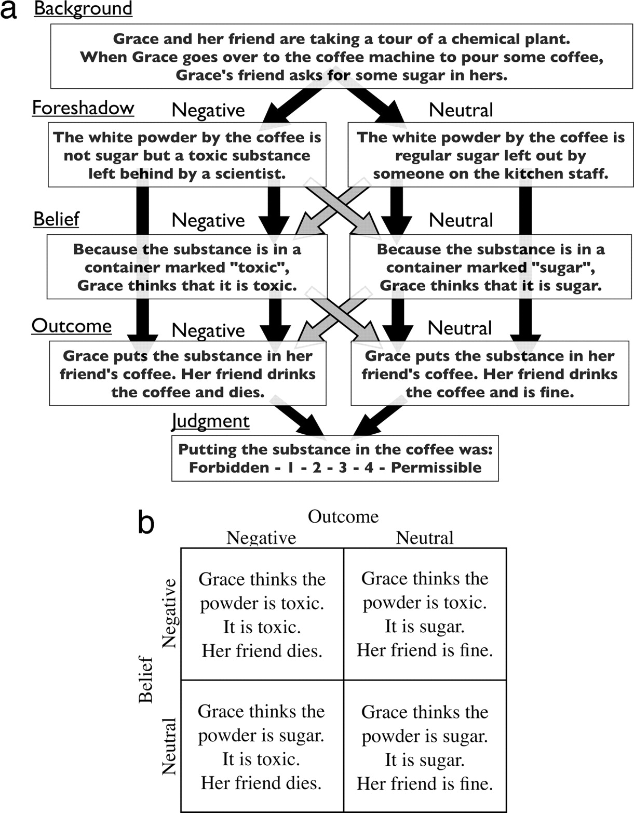

Figure 1. A 2×2 interaction of the two variables constituting the four conditions of the experiment.

**2.4 Experimental Procedure**

The experiment is adapted from the moral-emotional task developed by Gan (Gan, 2013; Gan et al., 2016). Intent-Outcome Moral Judgement of Hurting Behaviour material as the material for the formal experiment and was a 2×2 (Outcome: Neutral and Negative × Intent: Neutral and Negative) between-group design for the “E” groups and “I” group which is divided according to their EQP-*T*-score. The formal experiment was divided into 10 groups of 40 trials, four trials per group, and all stories were presented in a pseudo-randomized order, with no repetitive episodes in the five consecutively appearing stories. The trial procedure begins with reading the background and foreshadowing of the story, after that subjects pressed the space bar to advance, and after reading the story, they were asked to perform five evaluations. Firstly, subjects were asked to evaluate the acceptability of the protagonist's behavior in the given scenarios (1=forbidden; 7=permissible), secondly, the moral emotion also needed to be evaluated by the participants when they looked at the story as a bystander. Based on previous research we chose the three emotions of anger (1=very angry; 7=no anger), disgust (1=very disgusting; 7=no disgust), and happiness (1=very happy; 7=no happy) as the main moral emotions to be studied, and finally we added a question that asked the subjects to rate how much punishment (1=no punishment; 7=need severe punishment) the story protagonist should receive thus further incorporating the relevance of their previous identity ratings (Figure 2) (Rozin et al., 1999). The procedure used PsychoP-2023.2.3 software to write the program, present the stimuli and record the subjects' responses.

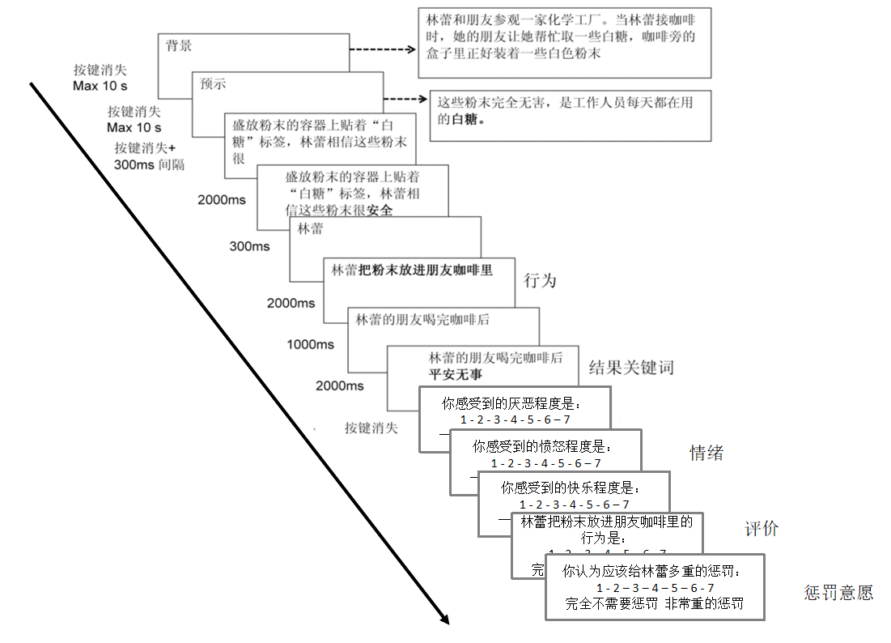

**Figure 2.** The procedure of moral judgment and emotion task.

1. **RESULTS**
   1. **Descriptive Statistics**

**Table 2.** Eysenck's factors of personality and scorings of each judgment task condition(*M*±*SE*).

|  |  |  |  |  |  |  |  |  |  |  |  |
| --- | --- | --- | --- | --- | --- | --- | --- | --- | --- | --- | --- |
| **Eysenck’s factor of personality** | | | | | | | | | | | |
| **E** (内外向) | | **N** (神经质) | | **P** (精神质) | | | **L** (掩饰性) | | |
| 55.73 ± 4.48 | | 57.91 ± 3.87 | | 48.54 ± 3.82 | | | 33.88 ± 3.51 | | |
|  | **Attempted harm**  (伤人未遂) | | **Successful harm**  (成功伤人) | | **No harm**  (无伤人) | | | **Accidental harm**  (意外伤人) | |
| **Moral judgment**  (道德评判) | 3.50 ± 0.39 | | 2.73 ± 0.45 | | 5.92 ± 0.27 | | | 4.01 ± 0.39 | |
| **Punishment intention**  (惩罚意愿) | | 3.88 ± 0.35 | | 4.65 ± 0.40 | | 1.96 ± 0.26 | | | 3.56 ± 0.33 | |
| **Feelings of disgust**  (厌恶情绪) | | 3.33 ± 0.39 | | 2.66 ± 0.45 | | 5.75 ± 0.28 | | | 3.97 ± 0.34 | |
| **Feelings of anger**  (愤怒情绪) | | 3.50 ± 0.38 | | 2.98 ± 0.44 | | 5.76 ± 0.28 | | | 3.99 ± 0.35 | |
| **Feelings of happiness**  (高兴情绪) | | 4.75 ± 0.34 | | 5.24 ± 0.49 | | 3.20 ± 0.24 | | | 4.85 ± 0.42 | |

**Note:** *M*: mean; *SE*: standard error. E: extraversion-introversion propensity scale; N: neuroticism/stability scale; P: psychoticism/socialization scale; L: lie/social desirability scale.

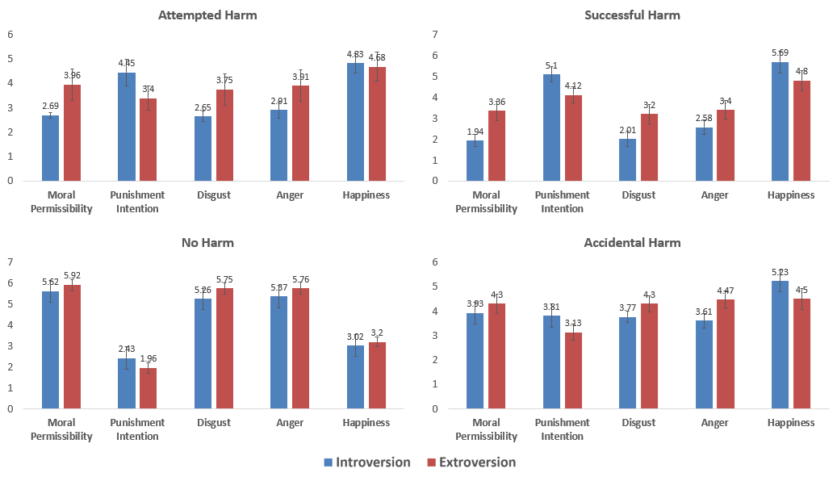

**Figure 3.** Mean scores and standard errors of Eysenck's factors of personality about ratings of each condition.

**Note:** *N* = 10; Error bars represent standard errors; Moral judgment: 1 = Completely prohibited, 7 = Completely permissible; Punitive intentions: 1 = No punishment needed, 7 = Very severe punishment needed; Disgust emotion: 1 = Very disgusted, 7 = Not disgusted at all; Anger emotion: 1 = Very angry, 7 = Not angry at all; Happiness emotion: 1 = Very happy, 7 = Not happy at all.

Table 2. presents the mean scores and standard errors of the Eysenck personality factors and ratings of each condition for all participants. Table 3. shows a comparative graph of scores after excluding one participant with an intermediate type and dividing the remaining participants into introverted and extraverted groups. It can be observed that there is a significant tendency for differences in results between the two groups of participants under different conditions. Specifically, in situations where there is an intention to harm, both in the case of attempted harm and successful harm, the average scores of the two groups differ by approximately 1 point in terms of moral judgment, punitive intentions, disgust emotion, and anger emotion. Compared to introverted individuals, extroverted individuals are more inclined to perceive harmful actions as permissible and have relatively lower punitive intentions. This may be due to their lower perceived levels of disgust and anger emotions. Under the condition of attempted harm, the difference in scores for happiness emotion between the introverted and extroverted groups is not significant. However, in the case of successful harm, introverted individuals tend to perceive less happiness emotion compared to extroverted individuals. Under the condition of no harm, there is not much difference in the ratings of various aspects between the two groups of participants. Under the condition of accidental harm, the difference in ratings between introverted and extroverted individuals is not as pronounced as in the case of attempted harm and successful harm, but it is also not as negligible as in the condition of no harm.

* 1. **Correlation Analysis**

**Table 3.** Correlation betweenEysenck's factors of personality and scorings of each judgment task condition (*N*=11).

|  |  |  |  |  |  |
| --- | --- | --- | --- | --- | --- |
|  |  | **Eysenck’s factor of personality** | | | |
|  |  | **E** (内外向) | **N** (神经质) | **P** (精神质) | **L** (掩饰性) |
| **Attempted harm**  (伤人未遂) | **Moral judgment** | 0.27 | 0.16 | 0.43 | –0.60 |
| **Punishment intention** | –0.39 | –0.22 | –0.42 | 0.47 |
| **Feelings of disgust** | –0.22 | 0.01 | –0.44 | 0.37 |
| **Feelings of anger** | –0.22 | –0.05 | –0.58 | 0.34 |
| **Feelings of happiness** | –0.10 | 0.59 | 0.76** | –0.76** |
| **Successful harm**  (成功伤人) | **Moral judgment** | 0.29 | –0.34 | 0.14 | –0.18 |
| **Punishment intention** | –0.40 | –0.11 | –0.23 | 0.45 |
| **Feelings of disgust** | –0.20 | 0.06 | –0.32 | 0.48 |
| **Feelings of anger** | –0.02 | –0.17 | –0.45 | –0.11 |
| **Feelings of happiness** | –0.10 | –0.11 | 0.38 | 0.59 |
| **No harm**  (无伤人) | **Moral judgment** | 0.12 | 0.70* | 0.57 | 0.57 |
| **Punishment intention** | –0.27 | –0.69* | –0.62* | 0.69* |
| **Feelings of disgust** | –0.26 | –0.66* | –0.61* | 0.77** |
| **Feelings of anger** | –0.21 | –0.76** | –0.60 | 0.75** |
| **Feelings of happiness** | –0.16 | 0.49 | 0.69* | -0.25 |
| **Accidental harm (意外伤人)** | **Moral judgment** | 0.06 | 0.46 | 0.34 | –0.57 |
| **Punishment intention** | –0.34 | –0.38 | –0.35 | 0.49 |
| **Feelings of disgust** | –0.17 | –0.20 | –0.05 | 0.26 |
| **Feelings of anger** | –0.47 | –0.03 | –0.19 | 0.26 |
| **Feelings of happiness** | –0.01 | –0.08 | 0.33 | –0.16 |

**Note:** *\*p*<0.05; \*\**p*<0.01; two-tailed test. E: extraversion-introversion propensity scale; N: neuroticism/stability scale; P: psychoticism/socialization scale; L: lie/social desirability scale.

Using Spearman correlation analysis, Table 3. presents the correlation matrix between Eysenck's factors of personality and ratings of each condition for all participants. Significant correlations mainly appear in conditions other than accidental harm and no harm, and they are related to variables other than extraversion-introversion propensity.

Figure 4 displays scatter plots of significant correlations between ratings. In the case of attempted harm, individuals with higher levels of extraversion tend to report higher levels of happiness emotion (Figure 4e.), while individuals with higher levels of deceitfulness tend to report lower levels of happiness emotion (Figure 4i.). Individuals with higher levels of neuroticism and greater emotional instability tend to report higher levels of moral permissibility (Figure 4a.), lower levels of punitive intentions (Figure 4b.), less disgust (Figure 4c.), and less anger emotion (Figure 4d.) under the condition of no harm. Furthermore, individuals with higher levels of extraversion, along with relatively more psychopathic personality traits, tend to report lower levels of punitive intentions (Figure 4f.), less disgust emotion (Figure 4g.), and more happiness emotion (Figure 4h.) under the condition of no harm. Participants with higher scores on deceitfulness tend to report higher levels of punitive intentions (Figure 4j.), more disgust (Figure 4k.), and more anger emotion (Figure 4l.) under the condition of no harm. No significant correlations were found between successful harm and accidental harm conditions, as well as significant correlations related to introversion and extraversion.

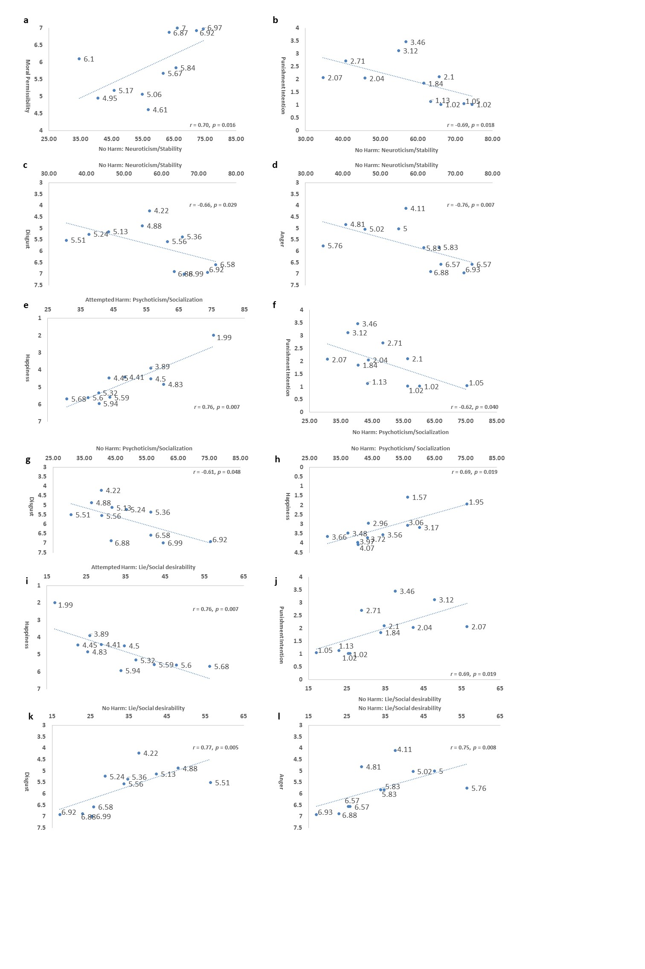

**Figure 4.** Mean scores and standard errors of the Eysenck personality three-factor model in relation to ratings of each condition.

**Note:** *N* = 11; Moral judgment: 1 = Completely prohibited, 7 = Completely permissible; Punitive intentions: 1 = No punishment needed, 7 = Very severe punishment needed; Disgust emotion: 1 = Very disgusted, 7 = Not disgusted at all; Anger emotion: 1 = Very angry, 7 = Not angry at all; Happiness emotion: 1 = Very happy, 7 = Not happy at all.

1. **DISCUSSIONS**

The current study has several potential limitations. One limitation is the insufficient sample size, which makes it challenging to identify relationships of high significance and unable to ensure that the results analyzed can be generalized to a larger population. Furthermore, the baseline emotional level of subjects was not measured before the experiment so it is incapable of comparing the changes in emotional state before and after the subjects’ participation. This is especially important for the reason that the preceding emotional state of subjects might influence the response and the decision they make during the moral judgment task. During the experiment, moral judgment and punishment intention were measured first and followed by the measurement of emotions; however, emotions are likely to be affected by the judgment the subjects made in the previous trials, thus, it is treated as a less crucial dependent variable and mainly focus on the differences in moral judgment and punishment intention, the ratings of emotions were post-positioned compared with former research designs. Since the moral judgment scenarios used in this study were modified based on the paradigm constructed by former research, its effectiveness in assessing the moral judgment competence of subjects has not been confirmed. Lastly, like all other moral dilemma research, the scenarios presented to the subjects in the current study are hypothetical and may not reflect real-life decisions at all times. While the use of ecologically effective stimuli is undoubtedly desirable, hypothetical stimuli remain valuable for the reason that they enable discrimination of various psychological processes and illustrate the processes that contribute to decision-making (Francis et al., 2017; Tao et al., 2020).

Future research could develop moral dilemma situations that are more realistic and practical, which would allow subjects to better immerse themselves in the context that is being described and yield results that are more valuable in understanding the connection between personality traits and moral judgment. In-depth exploration might require the integration of neuroimaging techniques to verify neuro-physiological variation among different personality trait groups in the context of moral decision-making.

**REFERENCES**

Broche-Pérez, Y., Herrera Jiménez, L. F., & Omar-Martínez, E. (2016). Neural substrates of decision-making. *Neurología (English Edition), 31*(5), 319-325. https://doi.org/10.1016/j.nrleng.2015.03.009

Eysenck, H. J., & Eysenck, S. B. G. (1975). *Manual of the Eysenck Personality Questionnaire (junior and adult)*. London: Hodder and Stoughton.

Eysenck, H. J., & Eysenck, S. B. G. (1993). *Eysenck Personality Questionnaire-Revised (EPQ-R)* [Database record]. APA PsycTests. https://doi.org/10.1037/t05461-000

Francis, K. B., Howard, C., Howard, I. S., Gummerum, M., Ganis, G., & Anderson, G. (2017). Correction: Virtual morality: transitioning from moral judgment to moral action? *PLoS One, 12*(1), e0170133. https://doi.org/10.1371/journal.pone.0170133

Gan, T. (2013). The neural mechanism and intervention of intention processing in moral judgment. [Doctoral dissertation, Beijing Normal University].

Gan, T., Lu, X., Li, W., Gui, D., Tang, H., Mai, X., Liu, C., & Luo, Y. (2016). Temporal dynamics of the integration of intention and outcome in harmful and helpful moral judgment. *Frontiers in Psychology, 6*(2022). https://doi.org/10.3389/fpsyg.2015.02022

Gong, Y. (1984). Eysenck Personality Questionnaire revised in China. *Information on Psychological Sciences, 4*, 11-18.

Heinzelmann, N., Ugazio, G., & Tobler, P. (2012). Pratical implcations of empitically studying moral decision-making. *Frontiers in Neuriscience, 6*, 94. https://doi.org/10.3389/fnins.2012.00094

Jin, W. Y., & Peng, M. (2021). The effects of social perception on moral judgement. *Frontiers in Psychology, 11*, 557216. https://doi.org/10.3389/fpsyg.2020.557216

Karandikar, S., Kapoor, H., Fernandes, S., & Jonason, P. K. (2019). Predicting moral decision-making with dark personalities and moral values. *Personality and Individual Differences, 140*, 70-75. https://doi.org/10.1016/j.paid.2018.03.048

Khani, A., & Rainer, G. (2016). Neural and neurochemical basis of reinforcement-guided decision making. *Journal of Neurophysiology, 116*(2), 724-741. https://doi.org/10.1152/jn.01113.2015

Lei, X., Yang, T., & Wu, T. (2015). Functional neuroimaging of Extraversion-Introversion. *Neuroscience Bulletin, 31*(6), 663-675. https://doi.org/10.007/s12264-015-1565-1

Malle, B. F. (2021). Moral judgments. *Annual Review of Psychology, 72*, 293-318. https://doi.org/10.1146/annurev-psych-072220-104358

Myers, I. B. (1962). *The Myers-Briggs Type Indictor: Manual (1962).* Consulting Psychologists Press. https://doi.org/10.1037/14404-000

Myyry, L. (2022). Moral judgments and values. *Encyclopedia of Violence, Peace, & Conflict (Thrid Edition), 4*, 331-338. https://doi.org/10.1016/B978-0-12-820195-4.00098-4

Pittenger, D. J. (1993). The utility of the Myers-Briggs Type Indicator. *Review of Educational Research, 63*(4), 467-488. https://doi.org/10.3102/00346543063004467

Qian, M., Wu, G., Zhu, R., & Zhang, S. (2000). Development of the revised Eysneck Personality Questionnaire Short Scale for Chinese (EPQ-RSC). *Acta Psychologica Sinica, 32*(03), 317-323. https://journal.psych.ac.cn/acps/EN/Y2000/V32/I03/317

Randall, K., Issacson, M., & Ciro, C. (2017). Validity and reliability of the Myers-BriggRandall, K., Isaacson, M., & Ciro, C. (2017). Validity and reliability of the Myers-Briggs Personality Type Indicator: a systematic review and meta-analysis. *Journal of Best Practices in Health Professions Diversity, 10*(1), 1-27. https://www.jstor/stable/26554264

Roccas, S., Sagiv, L., Schwartz, S. H., & Knafo, A. (2002). The Big Five personality factors and personal values. *Personality and Social Psychology Bulletin, 28*(6), 789-810. https://doi.org/10.1177/0146167202289008

Rozin, P., Lowery, L., Imada, S., & Haidt, J. (1999). The CAD triad hypothesis: a mapping between three moral emotions (contempt, anger, disgust) and three moral codes (community, autonomy, divinity). *Journal of Personality and Social Psychology, 76*(4), 574-586. https://doi.org/10.1037//0022-3514.76.4.574

Satow, L. (2021). Reliability and validity of the enhanced Big Five Personality Test (B5T). https://doi.org/10.31234/osf.io/wsugv

Tao, Y., Ying, C., Rana, C., & Zhong, Y. (2020). The impact of the Extraversion-Introversion personality traits and emotions in a moral decision-making task. *Personality and Individual Difference, 158*, 109840. https://doi.org/10.1016/j.paid.2020.109840

Young, L., Cushman, F., Hauser, M., & Saxe, R. (2007). The neural basis of the interaction between theory of mind and moral judgment. *PNAS*, *104*(20), 8235-8240. https://doi.org/10.1073/pnas.0701408104